Министерство образования Республики Беларусь

Учреждение образования

БЕЛОРУССКИЙ ГОСУДАРСТВЕННЫЙ УНИВЕРСИТЕТ  
ИНФОРМАТИКИ И РАДИОЭЛЕКТРОНИКИ

Факультет компьютерных систем и сетей

Кафедра электронных вычислительных машин

Дисциплина: Оборудование компьютерных сетей

ОТЧЕТ

по лабораторной работе № 2

ВАРИАНТ 11

Выполнил: А.Н. Климович

Проверил: И.И. Глецевич

МИНСК 2024

**1 ПРАКТИЧЕСКАЯ ЧАСТЬ**

**1.1 Часть рабочей конфигурации Switch 1(N1)**

hostname N1

!

enable password 1234

!

ip domain-name main.com

!

username alexei privilege 1 password 0 1234

!

spanning-tree mode pvst

!

interface FastEthernet0/1

switchport trunk native vlan 100

switchport trunk allowed vlan 10,20,30,100

switchport mode trunk

!

interface FastEthernet0/2

shutdown

!

…

!

interface FastEthernet0/24

shutdown

!

interface GigabitEthernet0/1

switchport trunk native vlan 100

switchport trunk allowed vlan 10,20,30,100

switchport mode trunk

!

interface GigabitEthernet0/2

switchport trunk native vlan 100

switchport trunk allowed vlan 10,20,30,100

switchport mode trunk

!

interface Vlan10

ip address 9.192.0.5 255.192.0.0

!

ip default-gateway 9.192.0.1

!

access-list 10 permit host 9.192.0.2

access-list 10 deny any

!

line vty 0 4

access-class 10 in

login local

transport input ssh

line vty 5 15

access-class 10 in

login local

transport input ssh

!

**1.2 Часть рабочей конфигурации Switch 2 (N2)**

hostname N2

!

enable password 1234

!

ip domain-name main.com

!

username alexei privilege 1 password 0 1234

!

spanning-tree mode pvst

!

interface FastEthernet0/1

switchport trunk native vlan 100

switchport trunk allowed vlan 10,20,30,100

switchport mode trunk

!

…

!

interface FastEthernet0/3

switchport trunk native vlan 100

switchport trunk allowed vlan 10,20,30,100

switchport mode trunk

!

interface FastEthernet0/4

shutdown

!

…

!

interface FastEthernet0/24

shutdown

!

interface GigabitEthernet0/1

shutdown

!

interface GigabitEthernet0/2

shutdown

!

interface Vlan10

ip address 9.192.0.6 255.192.0.0

!

ip default-gateway 9.192.0.1

!

access-list 10 permit host 9.192.0.2

access-list 10 deny any

!

line vty 0 4

access-class 10 in

login local

transport input ssh

line vty 5 15

access-class 10 in

login local

transport input ssh

!

**1.3 Часть рабочей конфигурации Switch 3 (N3)**

hostname N3

!

enable password 1234

!

ip domain-name main.com

!

username alexei privilege 1 password 0 1234

!

spanning-tree mode pvst

!

interface FastEthernet0/1

switchport trunk native vlan 100

switchport trunk allowed vlan 10,20,30,100

switchport mode trunk

!

interface FastEthernet0/2

switchport trunk native vlan 100

switchport trunk allowed vlan 10,20,30,100

switchport mode trunk

!

interface FastEthernet0/3

shutdown

!

…

!

interface FastEthernet0/24

shutdown

!

interface GigabitEthernet0/1

shutdown

!

interface GigabitEthernet0/2

shutdown

!

interface Vlan10

ip address 9.192.0.7 255.192.0.0

!

ip default-gateway 9.192.0.1

!

access-list 10 permit host 9.192.0.2

access-list 10 deny any

!

line vty 0 4

access-class 10 in

login local

transport input ssh

line vty 5 15

access-class 10 in

login local

transport input ssh

!

**1.4 Часть рабочей конфигурации Switch 4 (N4)**

hostname N4

!

enable password 1234

!

ip domain-name main.com

!

username alexei privilege 1 password 0 1234

!

spanning-tree mode pvst

!

interface FastEthernet0/1

switchport trunk native vlan 100

switchport trunk allowed vlan 10,20,30,100

channel-group 1 mode on

switchport mode trunk

duplex full

speed 100

!

interface FastEthernet0/2

switchport trunk native vlan 100

switchport trunk allowed vlan 10,20,30,100

channel-group 1 mode on

switchport mode trunk

duplex full

speed 100

!

interface FastEthernet0/3

shutdown

!

…

!

interface FastEthernet0/24

shutdown

!

interface GigabitEthernet0/1

switchport trunk native vlan 100

switchport trunk allowed vlan 10,20,30,100

switchport mode trunk

!

interface GigabitEthernet0/2

switchport trunk native vlan 100

switchport trunk allowed vlan 10,20,30,100

switchport mode trunk

!

interface Port-channel 1

switchport trunk native vlan 100

switchport trunk allowed vlan 10,20,30,100

switchport mode trunk

!

interface Vlan10

ip address 9.192.0.4 255.192.0.0

!

ip default-gateway 9.192.0.1

!

access-list 10 permit host 9.192.0.2

access-list 10 deny any

!

line vty 0 4

access-class 10 in

login local

transport input ssh

line vty 5 15

access-class 10 in

login local

transport input ssh

!

**1.5 Часть рабочей конфигурации Switch 5 (N5)**

hostname N5

!

enable password 1234

!

ip domain-name main.com

!

username alexei privilege 1 password 0 1234

!

spanning-tree mode pvst

!

interface FastEthernet0/1

switchport access vlan 10

switchport mode access

switchport port-security

switchport port-security mac-address sticky

switchport port-security violation protect

switchport port-security mac-address sticky 0004.9AD0.284E

spanning-tree portfast

spanning-tree bpduguard enable

!

interface FastEthernet0/2

switchport access vlan 20

switchport mode access

spanning-tree portfast

spanning-tree bpduguard enable

!

interface FastEthernet0/3

switchport access vlan 30

switchport mode access

spanning-tree portfast

spanning-tree bpduguard enable

!

interface FastEthernet0/4

shutdown

!

…

!

interface FastEthernet0/24

shutdown

!

interface GigabitEthernet0/1

switchport trunk native vlan 100

switchport trunk allowed vlan 10,20,30,100

switchport mode trunk

!

interface GigabitEthernet0/2

shutdown

!

interface Vlan10

ip address 9.192.0.9 255.192.0.0

!

ip default-gateway 9.192.0.1

!

access-list 10 permit host 9.192.0.2

access-list 10 deny any

!

line vty 0 4

access-class 10 in

login local

transport input ssh

line vty 5 15

access-class 10 in

login local

transport input ssh

!

**1.6 Часть рабочей конфигурации Switch 6 (N6)**

hostname N6

!

enable password 1234

!

ip domain-name main.com

!

username alexei privilege 1 password 0 1234

!

spanning-tree mode pvst

!

interface FastEthernet0/1

switchport access vlan 20

switchport mode access

spanning-tree portfast

spanning-tree bpduguard enable

!

interface FastEthernet0/2

switchport access vlan 20

switchport mode access

spanning-tree portfast

spanning-tree bpduguard enable

!

interface FastEthernet0/3

switchport access vlan 30

switchport mode access

spanning-tree portfast

spanning-tree bpduguard enable

!

interface FastEthernet0/4

switchport trunk native vlan 100

switchport trunk allowed vlan 10,20,30,100

switchport mode trunk

!

interface FastEthernet0/5

shutdown

!

…

!

interface FastEthernet0/24

shutdown

!

interface GigabitEthernet0/1

switchport trunk native vlan 100

switchport trunk allowed vlan 10,20,30,100

switchport mode trunk

!

interface GigabitEthernet0/2

shutdown

!

interface Vlan10

ip address 9.192.0.3 255.192.0.0

!

ip default-gateway 9.192.0.1

!

access-list 10 permit host 9.192.0.2

access-list 10 deny any

!

line vty 0 4

access-class 10 in

login local

transport input ssh

line vty 5 15

access-class 10 in

login local

transport input ssh

!

**1.7 Часть рабочей конфигурации Switch 7 (N7)**

hostname N7

!

enable password 1234

!

ip domain-name main.com

!

username alexei privilege 1 password 0 1234

!

spanning-tree mode pvst

!

interface FastEthernet0/1

switchport trunk native vlan 100

switchport trunk allowed vlan 10,20,30,100

switchport mode trunk

!

interface FastEthernet0/2

shutdown

!

…

!

interface FastEthernet0/24

shutdown

!

interface GigabitEthernet0/1

switchport trunk native vlan 100

switchport trunk allowed vlan 10,20,30,100

switchport mode trunk

!

interface GigabitEthernet0/2

switchport trunk native vlan 100

switchport trunk allowed vlan 10,20,30,100

switchport mode trunk

!

interface Vlan10

ip address 9.192.0.8 255.192.0.0

!

ip default-gateway 9.192.0.1

!

access-list 10 permit host 9.192.0.2

access-list 10 deny any

!

line vty 0 4

access-class 10 in

login local

transport input ssh

line vty 5 15

access-class 10 in

login local

transport input ssh

!

**1.8 Часть рабочей конфигурации Switch 8 (N8)**

hostname N8

!

enable password 1234

!

ip routing

!

username alexei password 0 1234

!

ip domain-name main.com

!

spanning-tree mode pvst

spanning-tree vlan 10,20,30,100 priority 24576

!

interface Port-channel 1

switchport trunk native vlan 100

switchport trunk allowed vlan 10,20,30,100

switchport trunk encapsulation dot1q

switchport mode trunk

!

interface FastEthernet0/1

channel-group 1 mode on

switchport trunk native vlan 100

switchport trunk allowed vlan 10,20,30,100

switchport trunk encapsulation dot1q

switchport mode trunk

duplex full

speed 100

!

interface FastEthernet0/2

channel-group 1 mode on

switchport trunk native vlan 100

switchport trunk allowed vlan 10,20,30,100

switchport trunk encapsulation dot1q

switchport mode trunk

duplex full

speed 100

!

interface FastEthernet0/3

shutdown

!

…

!

interface FastEthernet0/24

shutdown

!

interface GigabitEthernet0/1

shutdown

!

interface GigabitEthernet0/2

shutdown

!

interface Vlan10

ip address 9.192.0.1 255.192.0.0

!

interface Vlan20

ip address 152.1.216.1 255.255.252.0

!

interface Vlan30

ip address 171.80.24.1 255.255.252.0

!

interface Vlan100

ip address 90.32.0.1 255.224.0.0

!

access-list 10 permit host 9.192.0.2

access-list 10 deny any

!

line vty 0 4

access-class 10 in

login local

transport input ssh

line vty 5 15

access-class 10 in

login local

transport input ssh

!

**1.9 IP Configuration Laptop0**

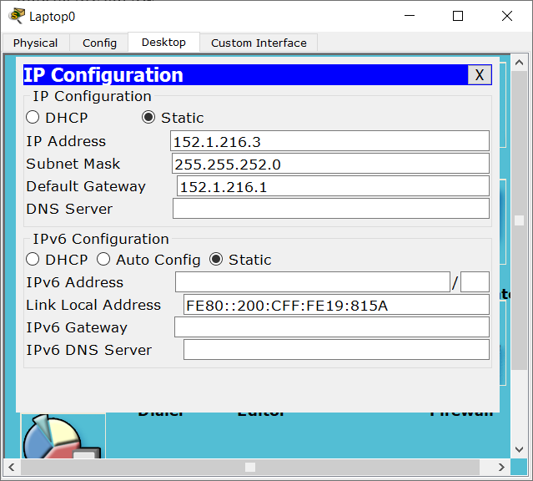

**1.10 IP Configuration Laptop1**

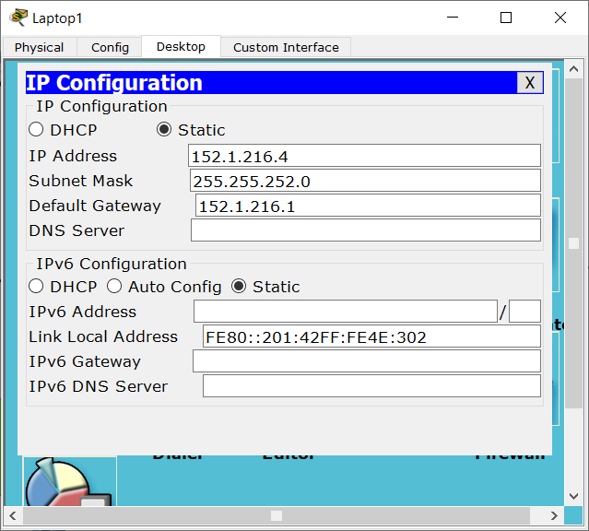

**1.11 IP Configuration Laptop2**

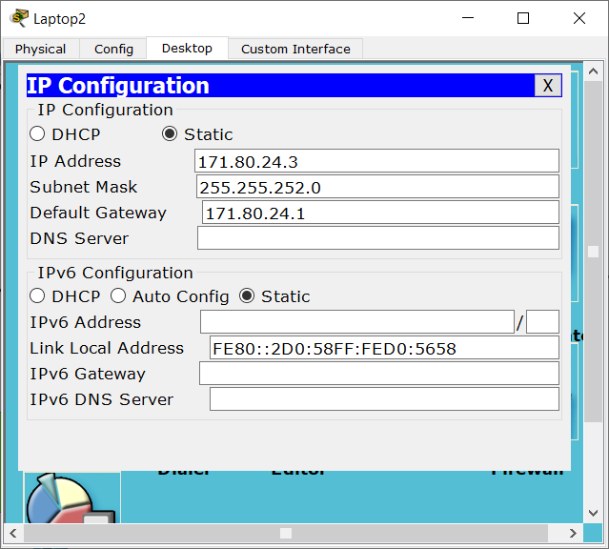

**1.12 IP Configuration PC0**

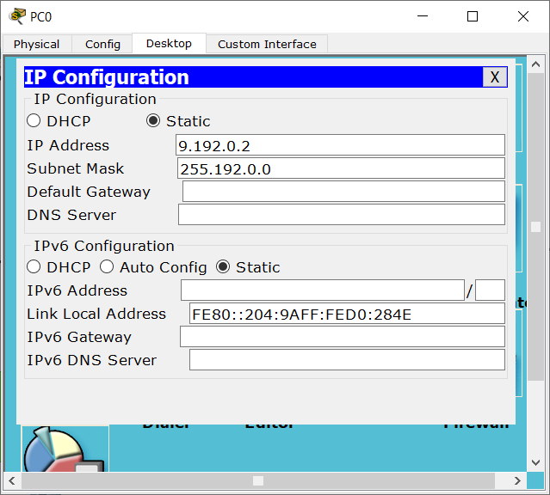

**1.13 IP Configuration PC1**

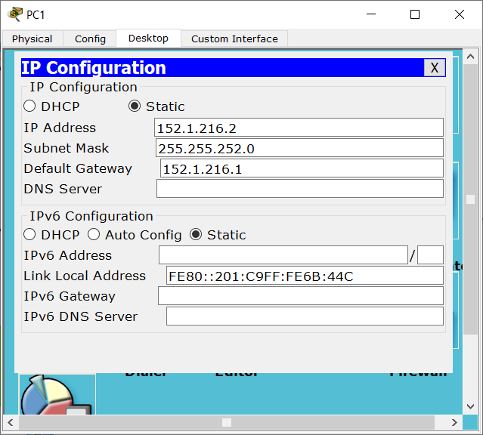

**1.14 IP Configuration PC2**

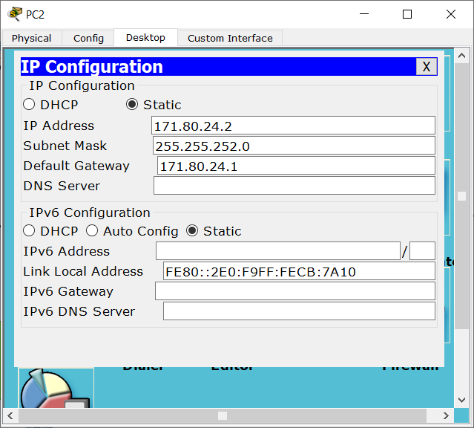

**РАБОЧИЕ МАТЕРИАЛЫ**

